Lab Cycle 1

1. Prepare a short note on the following hardware components.

a. Motherboard
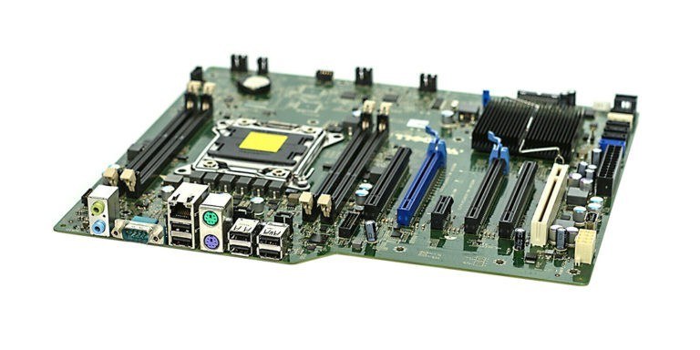
A motherboard (also called mainboard, main circuit board, MB, mboard, backplane board, baseboard, system board, mobo; or in Apple computers logic board) is the main printed circuit board (PCB)in general-purpose computers and other expandable systems. It holds and allows communication betweenmany of the crucial electronic components of a system, such as the central processing unit (CPU) andmemory, and provides connectors for other peripherals. Unlike a backplane, a motherboard usually containssignificant sub-systems, such as the central processor, the chipset's input/output and memory controllers,interface connectors, and other components integrated for general use.
Motherboard means specifically a PCB with expansion capabilities. As the name suggests, this board isoften referred to as the "mother" of all components attached to it, which often include peripherals, interfacecards, and daughterboards: sound cards, video cards, network cards, host bus adapters, TV tuner cards,IEEE 1394 cards, and a variety of other custom components.

b. Internal storage devices
i. RAM- different types
RAM (Random-access memory) is a form of electronic computer memory that can be read and changed in any order, typically used to store working data and machine code. A random-access memory device allows data items to be read or written in almost the same amount of time irrespective of the physical location of data inside the memory, in contrast with other direct-access data storage media (such as hard disks, CD-RWs, DVD-RWs and the older magnetic tapes and drum memory), where the time required to read and write data items varies significantly depending on their physical locations on the recording medium, due to mechanical limitations such as media rotation speeds and arm movement.
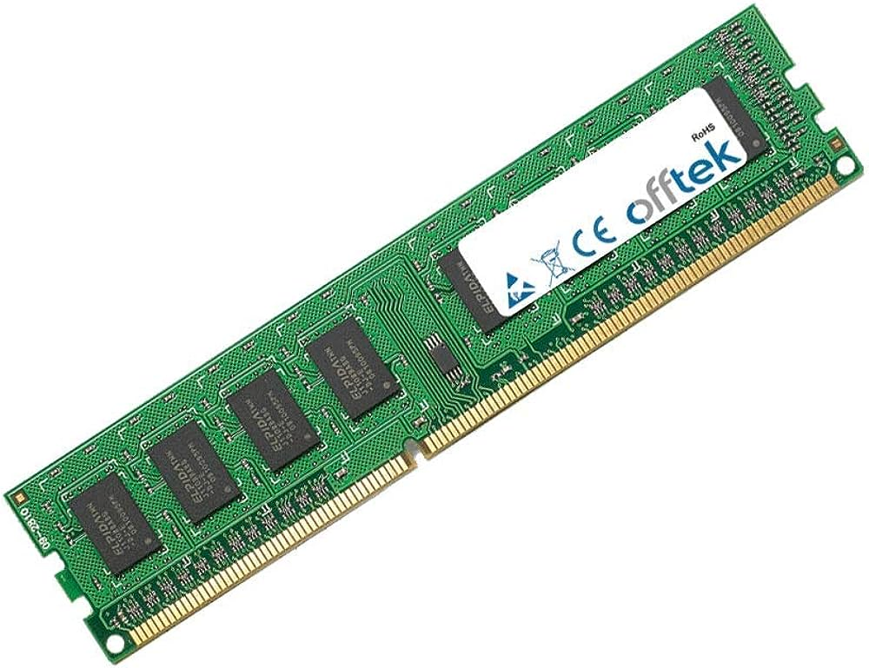

Different type of ram
1.SRAM
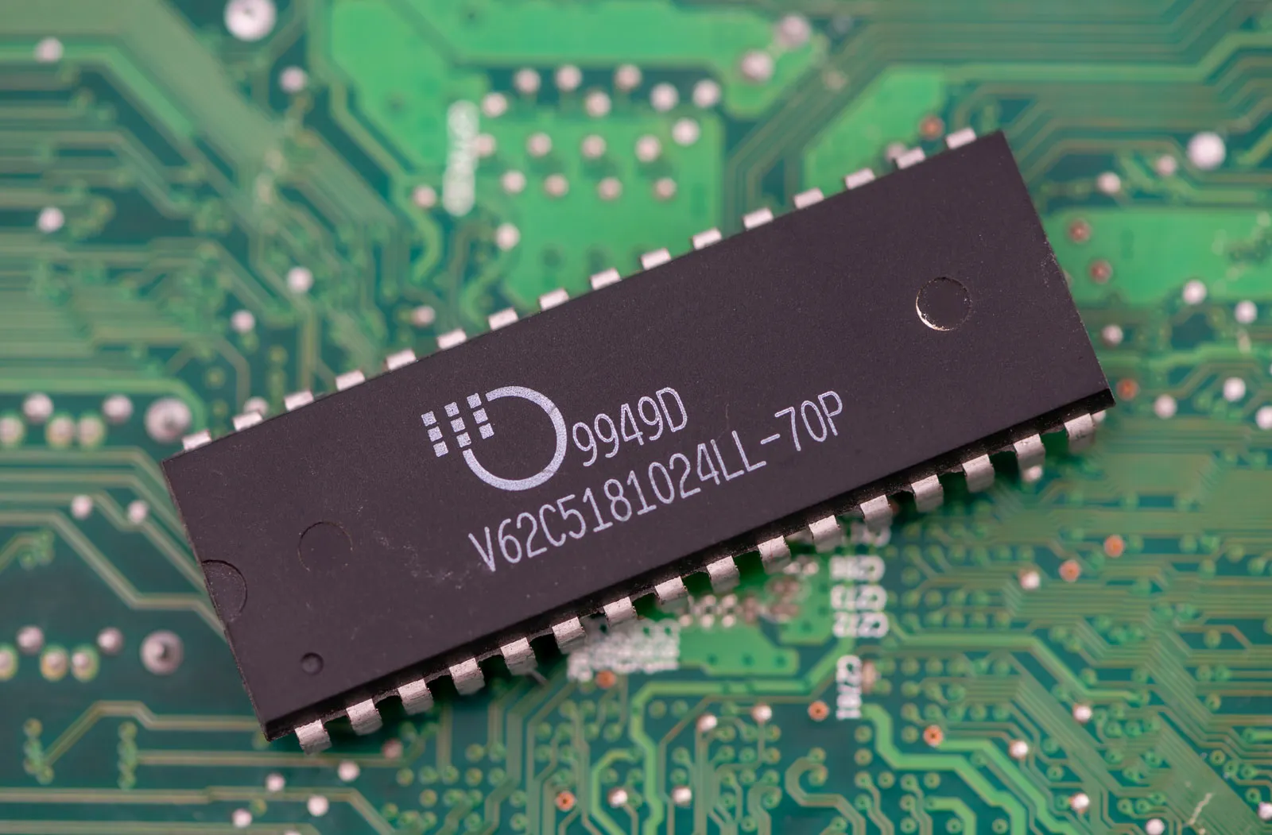

SRAM (static RAM) is a type of random access memory (RAM) that retains data bits in its memory as long as power is being supplied. Unlike dynamic RAM (DRAM), which must be continuously refreshed, SRAM does not have this requirement, resulting in better performance and lower power usage.
2.DRAM
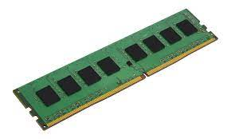

Dynamic random access memory (DRAM) is a type of semiconductor memory that is typically used for the data or program code needed by a computer processor to function. DRAM is a common type of random access memory (RAM) used in personal computers (PCs), workstations, and servers.

ii. ROM
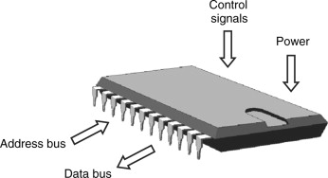

ROM is an acronym for Read-Only Memory. It refers to computer memory chips containing permanent or semi-permanent data. Unlike RAM, ROM is non-volatile; even after you turn off your computer, the contents of ROM will remain. Almost every computer comes with a small amount of ROM containing the boot firmware.

iii. Hard Disk
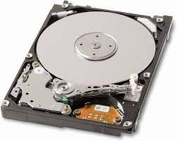

Hard disk, magnetic storage medium for a computer. Hard disks are flat circular plates made of aluminum or glass and coated with a magnetic material. Hard disks for personal computers can store terabytes (trillions of bytes) of information. Data are stored on their surfaces in concentric tracks.
c. SMPS
A switched-mode power supply (SMPS) is an electronic circuit that converts power using switching devices that are turned on and off at high frequencies, and storage components such as inductors or capacitors to supply power when the switching device is in its non-conduction state.
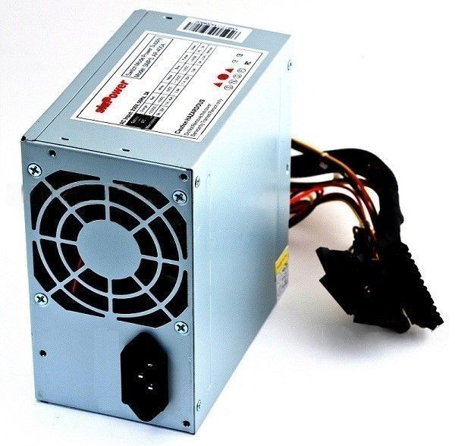

Advantages of switched-mode power supplies:
- Higher efficiency of 68% to 90%
- Regulated and reliable outputs regardless of variations in input supply voltage
- Small size and lighter
- Flexible technology
- High power density
Disadvantages:
- Generates electromagnetic interference
- Complex circuit design
- Expensive compared to linear supplies
Switched-mode power supplies are used to power a wide variety of equipment such as computers, sensitive electronics, battery-operated devices and other equipment requiring high efficiency.
d. daughter cards
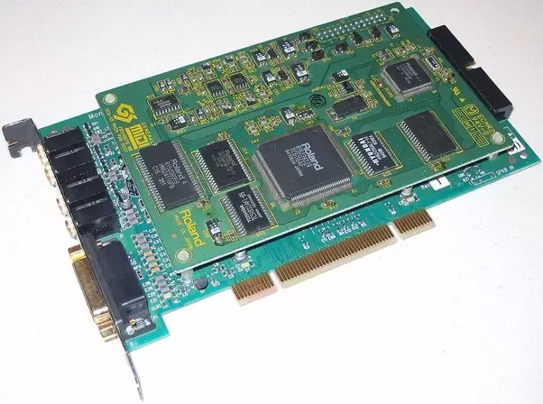

A daughterboard, daughtercard, mezzanine board or piggyback board is an expansion card that attaches to a system directly. Daughterboards often have plugs, sockets, pins or other attachments for other boards.
e. Bus slots
Also known as a bus slot or expansion port, the expansion slot is a connection port inside a computer’s motherboard. It is akin to a socket on the motherboard, used to insert expansion cards which provide a computer with upgraded capabilities such as a video card for upgraded graphics processing capabilities, superior sound output, ethernet, or even memory. Any slot on the motherboard that can hold an expansion card to expand the computer’s functionality can be referred to as an expansion slot.
f. Interfacing ports
A computer is a device that transforms data into meaningful information. It processes the input according to the set of instructions provided to it by the user and gives the desired output. As we know that we can connect multiple external devices with the computer system. Now, these devices are connected with the computer using Ports. The ports are the physical docking points present in the computer through which the external devices are connected using cables. Or in other words, a port is an interface between the motherboard and an external device of the computer. There are different types of ports available:
- Serial port
- Parallel port
- USB port
- PS/2 port
- VGA port
- Modem port
- FireWire Port
- Sockets
- Infrared Port
- Game Port
- Digital Video Interface(DVI) Port
- Ethernet Port

2. Write the specification for a desktop computer.

Processor (CPU): | Intel Core i5 (sixth generation or newer) or equivalent
Operating System: | Microsoft Windows 10 Professional x64  (free via Azure Dev Tools for Teaching. Restrictions apply.)
Memory: | 16 GB RAM
Storage: | 500 GB internal storage drive
Monitor/Display: | 14" LCD monitor, resolution of 1600 x 900 or better.
Network Adapter: | 802.11ac 2.4/5 GHz wireless adapter
Other: | Internal or external Webcam, lock, carrying case, external hard drive for backups

3. Write the specification for a server computer.
RAM: The RAM capacity required will depend on the type of computer server that will be used. If you need a computer server only as a data management system, then the minimum RAM capacity required is 2GB. You can upgrade the RAM according to your needs up to 8GB capacity
Processor: Two types of processors that are frequently used for computers, namely Intel and AMD. Each has advantages and disadvantages you can compare and discuss with the IT team according to your company needs.
Storage: The thing that is no less important to consider in a computer server is a storage device. You need to consider the device used and also its capacity. These considerations, of course, depend on your company needs

4. Write short note on the following.
a. Operating System
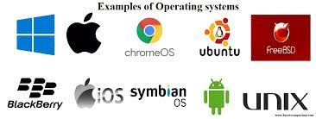

An operating system is the most important software that runs on a computer. It manages the computer's memory and processes, as well as all of its software and hardware. It also allows you to communicate with the computer without knowing how to speak the computer's language.
b. Linux
Linux offers a high degree of capability and has a wide range of applications developers can use. Due to its free, open-source nature, several varieties of Linux exist and are constantly being built upon to create new OS versions, or distributions, that offer specific capabilities to fulfill the immediate needs of the developer. Although many distributions require the user to interact with the Linux OS through the command line interface, there are plenty of distributions that come with a graphical user interface (GUI), more closely resembling a typical desktop for Windows PC or Mac. Some of the most popular Linux distributions include Ubuntu, Red Hat, Fedora, Oracle Linux, CentOS and Debian.
c. Ubuntu
Ubuntu is a Linux-based operating system. It is designed for computers, smartphones, and network servers. The system is developed by a UK based company called Canonical Ltd. All the principles used to develop the Ubuntu software are based on the principles of Open Source software development.
d. Virtual Machine
A virtual machine (VM) is a digital version of a physical computer. Virtual machine software can run programs and operating systems, store data, connect to networks, and do other computing functions, and requires maintenance such as updates and system monitoring.
e. Kernel
Kernel acts as a bridge between applications and data processing performed at hardware level using inter-process communication and system calls. Kernel loads first into memory when an operating system is loaded and remains into memory until operating system is shut down again.
f. Shell
The shell provides you with an interface to the UNIX system. It gathers input from you and executes programs based on that input. When a program finishes executing, it displays that program's output. A shell is an environment in which we can run our commands, programs, and shell scripts.
g. Terminal
Terminals are divided into different classes depending on whether they are able to process data on their own. Dumb terminals — display monitor or simple input/output (I/O) devices that send and accept data from a network server or mainframe. They have no built-in processing capabilities.
h. Bash
Bash, the Bourne-Again Shell, refers both to a particular Unix shell program and its associated scripting language. It is the default shell of the GNU Operating System (Linux) and Apple's OS X and is POSIX 1003.2 compliant. It is a powerful shell, and features, among other things: Command line editing.
i. Shell scripting
Shell scripting is a powerful tool commonly used across industries to automate tasks, test solutions, and increase efficiency. Shell scripting is a text file with a list of commands that instruct an operating system to perform certain tasks.

